Support Vector Machines is considered to be a classification approach, but it can be employed in both types of classification and regression problems. It can easily handle multiple continuous and categorical variables. SVM constructs a hyperplane in multidimensional space to separate different classes. SVM generates optimal hyperplane in an iterative manner, which is used to minimize an error. The core idea of SVM is to find a maximum marginal hyperplane(MMH) that best divides the dataset into classes.

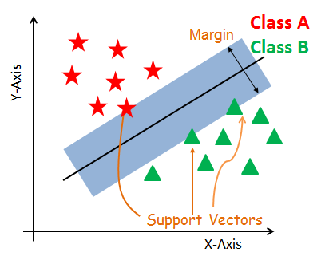

Support Vectors

Support vectors are the data points, which are closest to the hyperplane. These points will define the separating line better by calculating margins. These points are more relevant to the construction of the classifier.

Hyperplane

A hyperplane is a decision plane which separates between a set of objects having different class memberships.

Margin

A margin is a gap between the two lines on the closest class points. This is calculated as the perpendicular distance from the line to support vectors or closest points. If the margin is larger in between the classes, then it is considered a good margin, a smaller margin is a bad margin.

How does SVM work?

The main objective is to segregate the given dataset in the best possible way. The distance between the either nearest points is known as the margin. The objective is to select a hyperplane with the maximum possible margin between support vectors in the given dataset. SVM searches for the maximum marginal hyperplane in the following steps:

1. Generate hyperplanes which segregates the classes in the best way. Left-hand side figure showing three hyperplanes black, blue and orange. Here, the blue and orange have higher classification error, but the black is separating the two classes correctly.
2. Select the right hyperplane with the maximum segregation from the either nearest data points as shown in the right-hand side figure.

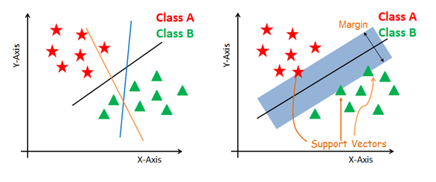

#### Dealing with non-linear and inseparable planes

Some problems can’t be solved using linear hyperplane, as shown in the figure below (left-hand side).

In such situation, SVM uses a kernel trick to transform the input space to a higher dimensional space as shown on the right. The data points are plotted on the x-axis and z-axis (Z is the squared sum of both x and y: z=x^2=y^2). Now you can easily segregate these points using linear separation.

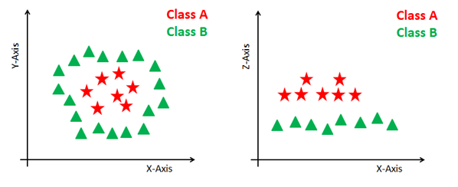

SVM Kernels

The SVM algorithm is implemented in practice using a kernel. A kernel transforms an input data space into the required form. SVM uses a technique called the kernel trick. Here, the kernel takes a low-dimensional input space and transforms it into a higher dimensional space. In other words, you can say that it converts nonseparable problem to separable problems by adding more dimension to it. It is most useful in non-linear separation problem. Kernel trick helps you to build a more accurate classifier.

Linear Kernel A linear kernel can be used as normal dot product any two given observations. The product between two vectors is the sum of the multiplication of each pair of input values.

K(x, xi) = sum(x * xi)

Polynomial Kernel A polynomial kernel is a more generalized form of the linear kernel. The polynomial kernel can distinguish curved or nonlinear input space.

K(x,xi) = 1 + sum(x * xi)^d

Where d is the degree of the polynomial. d=1 is similar to the linear transformation. The degree needs to be manually specified in the learning algorithm.

Radial Basis Function Kernel The Radial basis function kernel is a popular kernel function commonly used in support vector machine classification. RBF can map an input space in infinite dimensional space.

K(x,xi) = exp(-gamma * sum((x – xi^2))

# Support Vector Machines with Scikit-learn

In this tutorial, you'll learn about Support Vector Machines, one of the most popular and widely used supervised machine learning algorithms.

SVM offers very high accuracy compared to other classifiers such as logistic regression, and decision trees. It is known for its kernel trick to handle nonlinear input spaces. It is used in a variety of applications such as face detection, intrusion detection, classification of emails, news articles and web pages, classification of genes, and handwriting recognition.

In this tutorial, you will be using scikit-learn in Python. If you would like to learn more about this Python package, I recommend you take a look at our [Supervised Learning with scikit-learn](https://www.datacamp.com/courses/supervised-learning-with-scikit-learn) course.

SVM is an exciting algorithm and the concepts are relatively simple. The classifier separates data points using a hyperplane with the largest amount of margin. That's why an SVM classifier is also known as a discriminative classifier. SVM finds an optimal hyperplane which helps in classifying new data points.

In this tutorial, you are going to cover following topics:

* [Support Vector Machines](https://www.datacamp.com/community/tutorials/svm-classification-scikit-learn-python#svm)
* [How does it work?](https://www.datacamp.com/community/tutorials/svm-classification-scikit-learn-python#how)
* [Kernels](https://www.datacamp.com/community/tutorials/svm-classification-scikit-learn-python#kernels)
* [Classifier building in Scikit-learn](https://www.datacamp.com/community/tutorials/svm-classification-scikit-learn-python#building)
* [Tuning Hyperparameters](https://www.datacamp.com/community/tutorials/svm-classification-scikit-learn-python#tuning)
* [Advantages and Disadvantages](https://www.datacamp.com/community/tutorials/svm-classification-scikit-learn-python#prosandcons)

## Support Vector Machines

Generally, Support Vector Machines is considered to be a classification approach, it but can be employed in both types of classification and regression problems. It can easily handle multiple continuous and categorical variables. SVM constructs a hyperplane in multidimensional space to separate different classes. SVM generates optimal hyperplane in an iterative manner, which is used to minimize an error. The core idea of SVM is to find a maximum marginal hyperplane(MMH) that best divides the dataset into classes.



#### Support Vectors

Support vectors are the data points, which are closest to the hyperplane. These points will define the separating line better by calculating margins. These points are more relevant to the construction of the classifier.

#### Hyperplane

A hyperplane is a decision plane which separates between a set of objects having different class memberships.

#### Margin

A margin is a gap between the two lines on the closest class points. This is calculated as the perpendicular distance from the line to support vectors or closest points. If the margin is larger in between the classes, then it is considered a good margin, a smaller margin is a bad margin.

## How does SVM work?

The main objective is to segregate the given dataset in the best possible way. The distance between the either nearest points is known as the margin. The objective is to select a hyperplane with the maximum possible margin between support vectors in the given dataset. SVM searches for the maximum marginal hyperplane in the following steps:

1. Generate hyperplanes which segregates the classes in the best way. Left-hand side figure showing three hyperplanes black, blue and orange. Here, the blue and orange have higher classification error, but the black is separating the two classes correctly.
2. Select the right hyperplane with the maximum segregation from the either nearest data points as shown in the right-hand side figure.



#### Dealing with non-linear and inseparable planes

Some problems can’t be solved using linear hyperplane, as shown in the figure below (left-hand side).

In such situation, SVM uses a kernel trick to transform the input space to a higher dimensional space as shown on the right. The data points are plotted on the x-axis and z-axis (Z is the squared sum of both x and y: z=x^2=y^2). Now you can easily segregate these points using linear separation.



## SVM Kernels

The SVM algorithm is implemented in practice using a kernel. A kernel transforms an input data space into the required form. SVM uses a technique called the kernel trick. Here, the kernel takes a low-dimensional input space and transforms it into a higher dimensional space. In other words, you can say that it converts nonseparable problem to separable problems by adding more dimension to it. It is most useful in non-linear separation problem. Kernel trick helps you to build a more accurate classifier.

* **Linear Kernel** A linear kernel can be used as normal dot product any two given observations. The product between two vectors is the sum of the multiplication of each pair of input values.

K(x, xi) = sum(x * xi)

* **Polynomial Kernel** A polynomial kernel is a more generalized form of the linear kernel. The polynomial kernel can distinguish curved or nonlinear input space.

K(x,xi) = 1 + sum(x * xi)^d

Where d is the degree of the polynomial. d=1 is similar to the linear transformation. The degree needs to be manually specified in the learning algorithm.

* **Radial Basis Function Kernel** The Radial basis function kernel is a popular kernel function commonly used in support vector machine classification. RBF can map an input space in infinite dimensional space.

K(x,xi) = exp(-gamma * sum((x – xi^2))

Here gamma is a parameter, which ranges from 0 to 1. A higher value of gamma will perfectly fit the training dataset, which causes over-fitting. Gamma=0.1 is considered to be a good default value. The value of gamma needs to be manually specified in the learning algorithm.

from sklearn import datasets

#Load dataset

cancer = datasets.load_breast_cancer()

# print the names of the 13 features

print("Features: ", cancer.feature_names)

# print the label type of cancer('malignant' 'benign')

print("Labels: ", cancer.target_names)

cancer.data.shape

# print the cancer data features (top 5 records)

print(cancer.data[0:5])

# print the cancer labels (0:malignant, 1:benign)

print(cancer.target)

# Import train_test_split function

from sklearn.model_selection import train_test_split

# Split dataset into training set and test set

X_train, X_test, y_train, y_test = train_test_split(cancer.data, cancer.target, test_size=0.3,random_state=109) # 70% training and 30% test

#Import svm model

from sklearn import svm

#Create a svm Classifier

clf = svm.SVC(kernel='linear') # Linear Kernel

#Train the model using the training sets

clf.fit(X_train, y_train)

#Predict the response for test dataset

y_pred = clf.predict(X_test)

#Import scikit-learn metrics module for accuracy calculation

from sklearn import metrics

# Model Accuracy: how often is the classifier correct?

print("Accuracy:",metrics.accuracy_score(y_test, y_pred))

# Model Precision: what percentage of positive tuples are labeled as such?

print("Precision:",metrics.precision_score(y_test, y_pred))

# Model Recall: what percentage of positive tuples are labelled as such?

print("Recall:",metrics.recall_score(y_test, y_pred))

**Tuning Hyperparameters**

* **Kernel**: The main function of the kernel is to transform the given dataset input data into the required form. There are various types of functions such as linear, polynomial, and radial basis function (RBF). Polynomial and RBF are useful for non-linear hyperplane. Polynomial and RBF kernels compute the separation line in the higher dimension. In some of the applications, it is suggested to use a more complex kernel to separate the classes that are curved or nonlinear. This transformation can lead to more accurate classifiers.
* **Regularization**: Regularization parameter in python's Scikit-learn C parameter used to maintain regularization. Here C is the penalty parameter, which represents misclassification or error term. The misclassification or error term tells the SVM optimization how much error is bearable. This is how you can control the trade-off between decision boundary and misclassification term. A smaller value of C creates a small-margin hyperplane and a larger value of C creates a larger-margin hyperplane.
* **Gamma**: A lower value of Gamma will loosely fit the training dataset, whereas a higher value of gamma will exactly fit the training dataset, which causes over-fitting. In other words, you can say a low value of gamma considers only nearby points in calculating the separation line, while the a value of gamma considers all the data points in the calculation of the separation line.

**Advantages**

SVM Classifiers offer good accuracy and perform faster prediction compared to Naïve Bayes algorithm. They also use less memory because they use a subset of training points in the decision phase. SVM works well with a clear margin of separation and with high dimensional space.

**Disadvantages**

SVM is not suitable for large datasets because of its high training time and it also takes more time in training compared to Naïve Bayes. It works poorly with overlapping classes and is also sensitive to the type of kernel used.